RSA 9.1 Installation Guide
Part 1: Installing the base software and Applying Licence (This assumes that Installation manager has not been installed yet.).
Pre-Conditions: You must have admin access on the computer you wish to install RSA.
Installer location: <NEM SHARE DRIVE>\Software\Installers - RSA
- Copy the ‘RSA 9.1’ folder that can be found in the Installer location over to your VM.
- On your VM navigate to …\RSA-9.1\RSA4WS_SETUP\ folder.
- Select the appropriate folder for your Windows Operating System:
  - For 32-Bit Windows: InstallerImage_win32_win32_x86
  - For 64-Bit Windows: InstallerImage_win32_win32_x86_64
- Right click on install.exe and then select ‘Run as administrator’ as shown below:
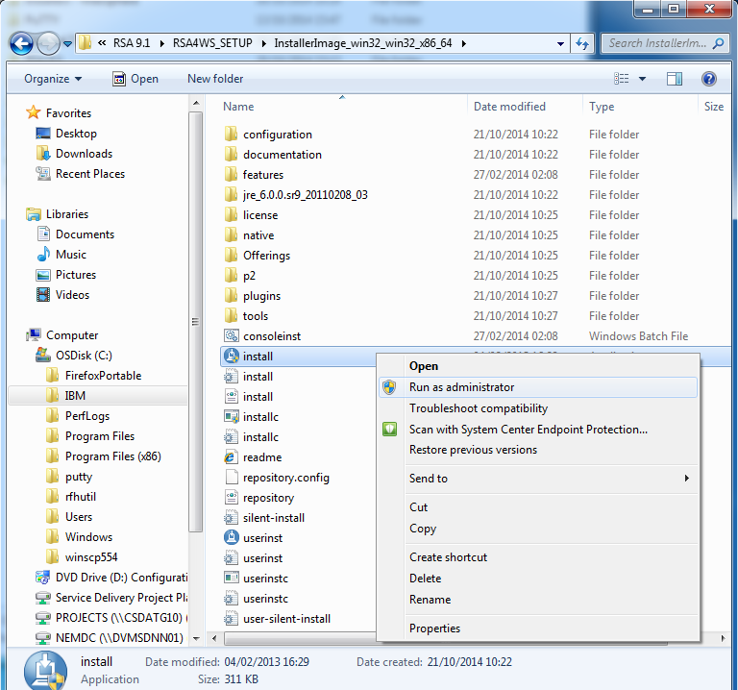

- Select ‘Yes’ if a user account control question pops up.
- The IBM Installation Manager will open up:
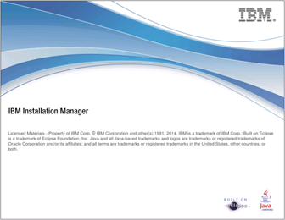
- Once the Installation Manager opens up, un-check the Installation Packages for “IBM WebSphere Application Server Liberty for Developers”. So now only IBM Installation Manager and IBM Rational Software Architect 9.1 will be selected. Click the ‘Next>’ button to continue. 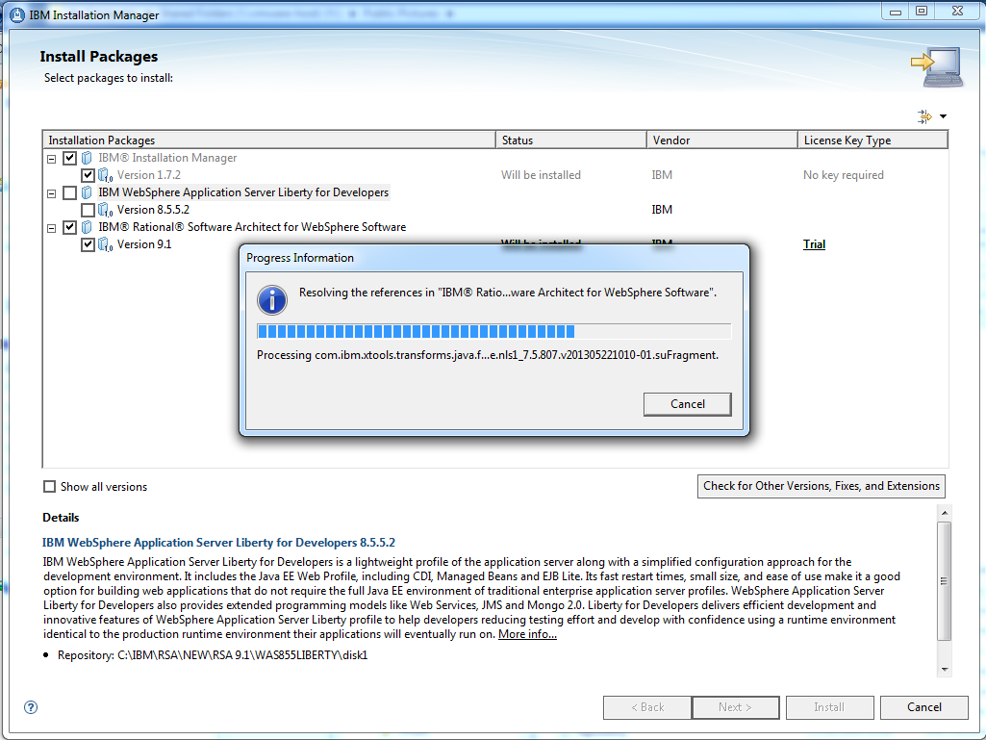
- You may get a “Validation Results” page like the one shown below. You can ignore this and click the ‘Next>’ button to continue. 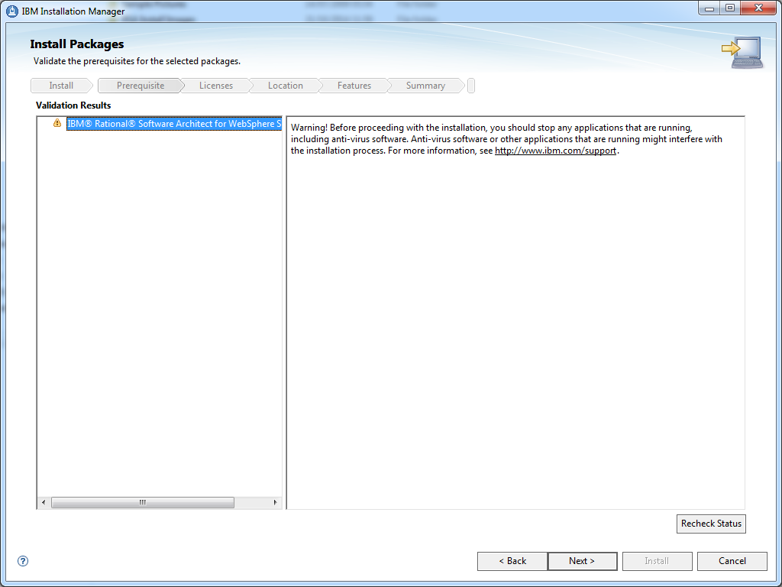
- On the License agreement page, click on the “I accept the terms in the license agreements” radio button and then Click the ‘Next>’ button to continue.
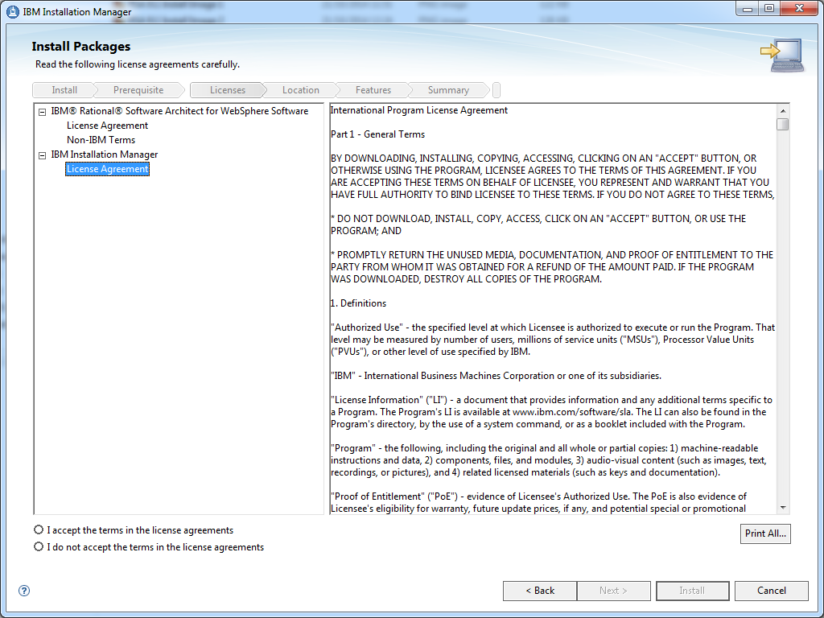
- On the next page, make no changes and click the ‘Next>’ button to continue.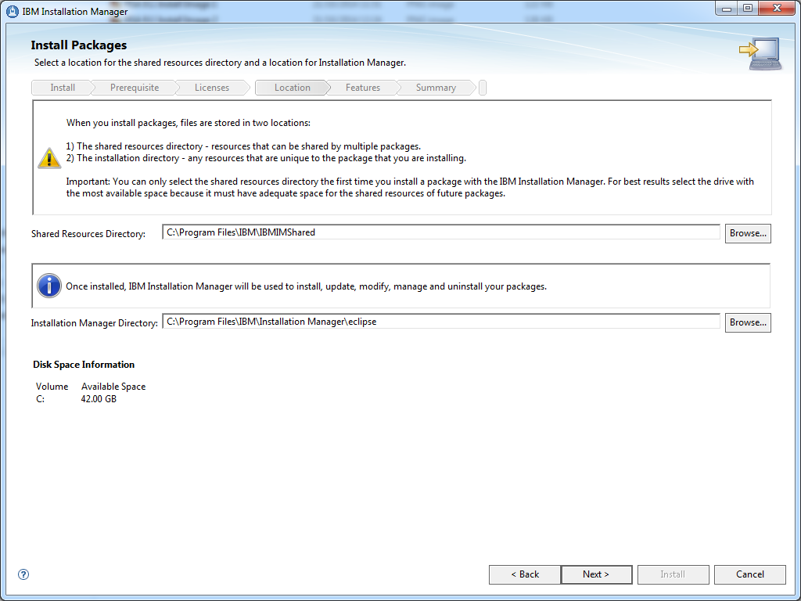
- On the next page, make sure the “Create a new package group” is selected and click the ‘Next>’ button to continue. 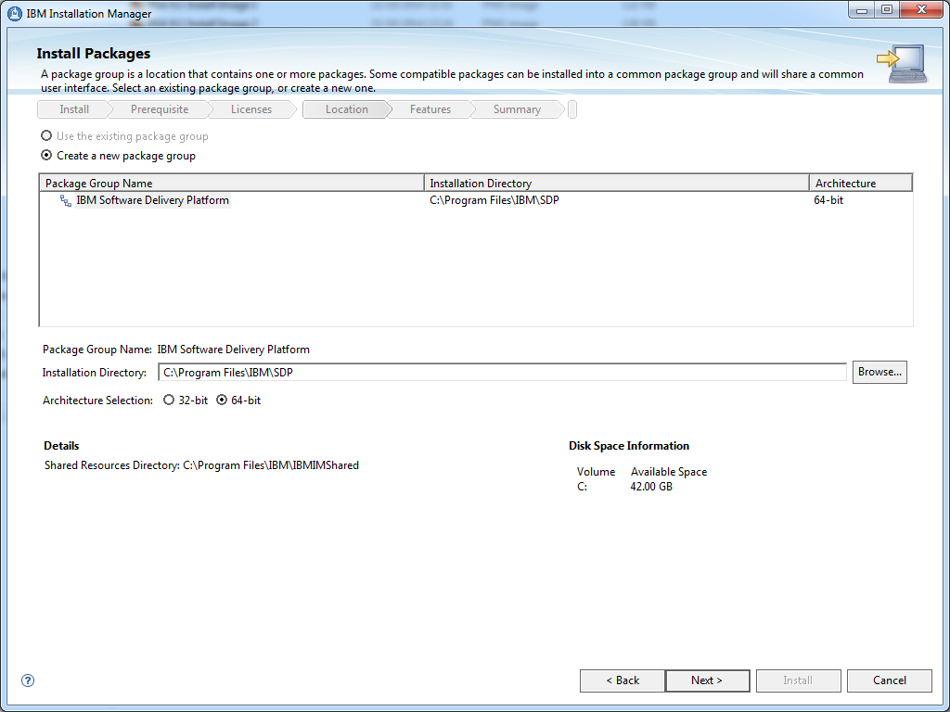
- Do not attempt to install the IBM Rational to an existing Eclipse environment. Leave these options blank and click ‘Next>’ to move to the next screen. 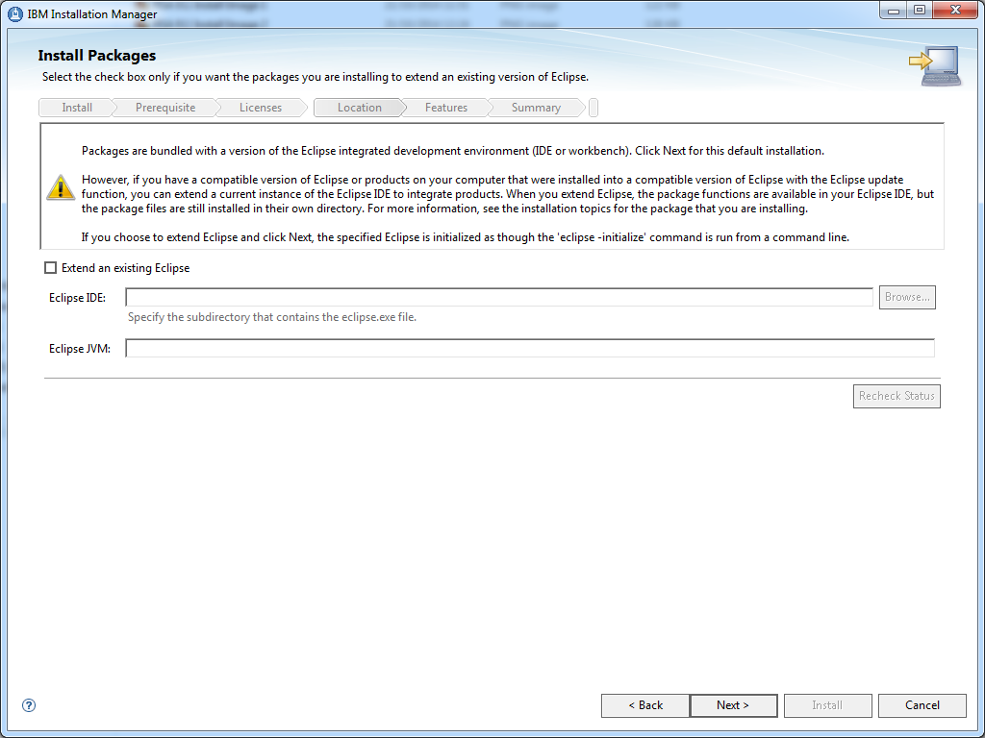
- Make sure that English is selected as the Language and then click ‘Next>’ to move to the next screen. 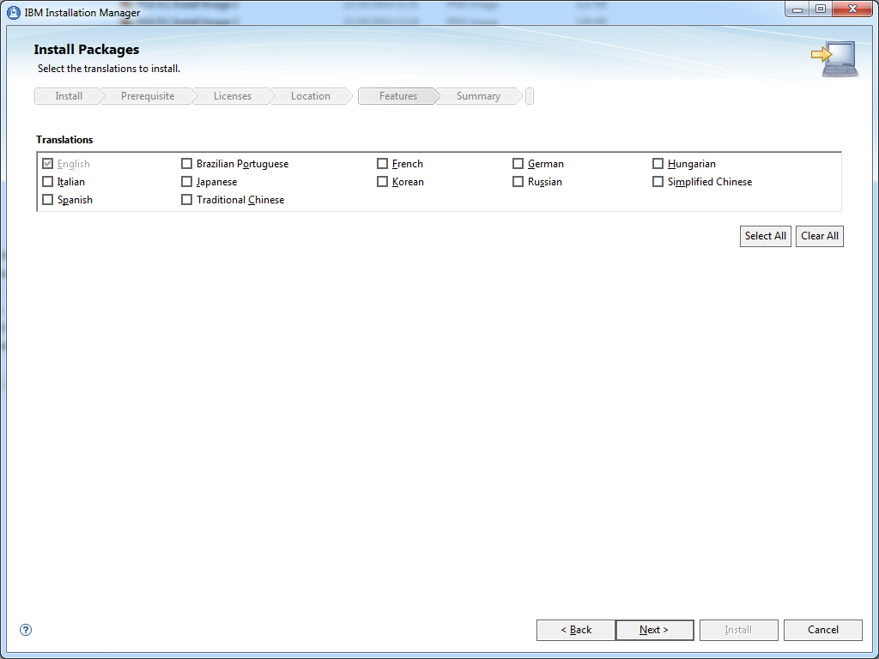

- The next screen allows you to pick different features to install. Make sure the following features are selected and then click the ‘Next>’ button to continue:
  - Architect – Minimal
  - Architect – Standard
  - Service Architect
  - Sketching
  - UML modeling
  - BPMN Modeling
  - Java Standard Edition and Java Persistence API (JPA) graphical editing and transformation
  - Modeling REST Services
  - Plug-in Development Environment (PDE)
  - Pluglets
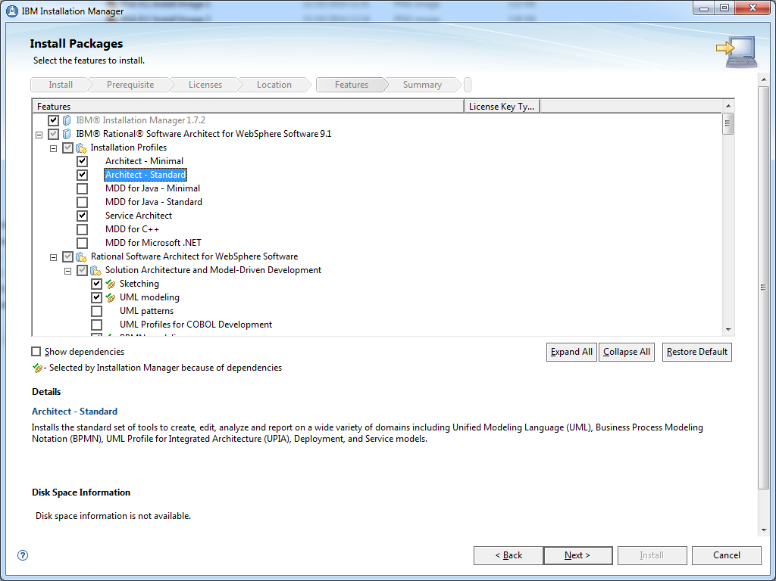
- Choose ‘Access Help from the Web’ and click the ‘Next>’ button to continue. 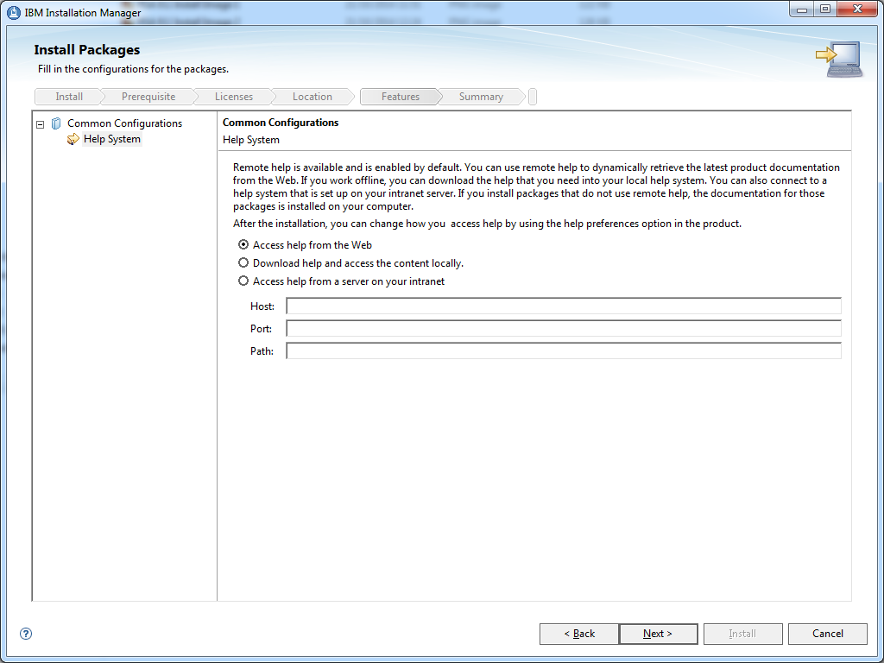

- At the final summary page, click the ‘Install’ button.
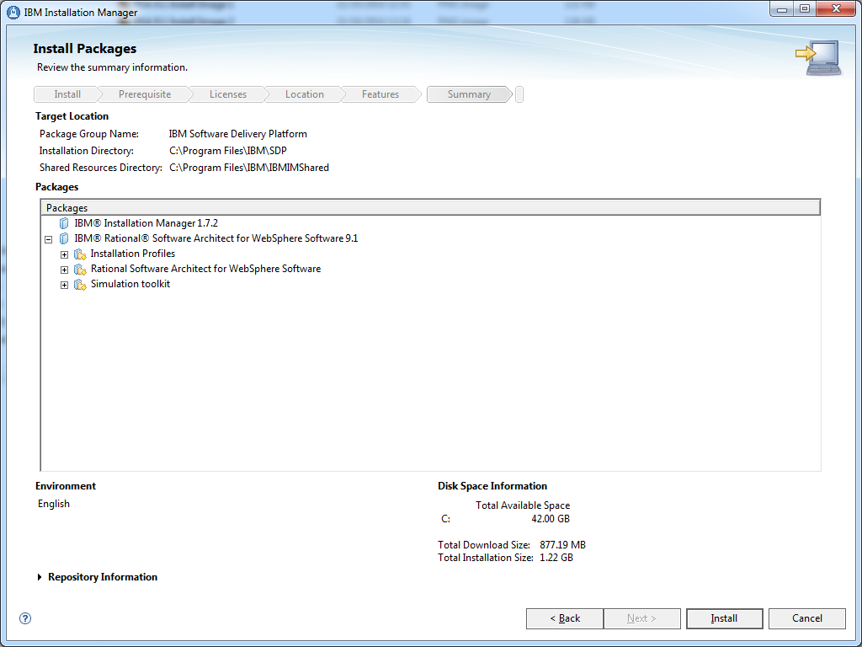
It may take up to 15 minutes for all of the files to be installed.
- Once completed, check the choice to start “IBM Rational Software Architect for WebSphere Software” and click the ‘Finish’ button. 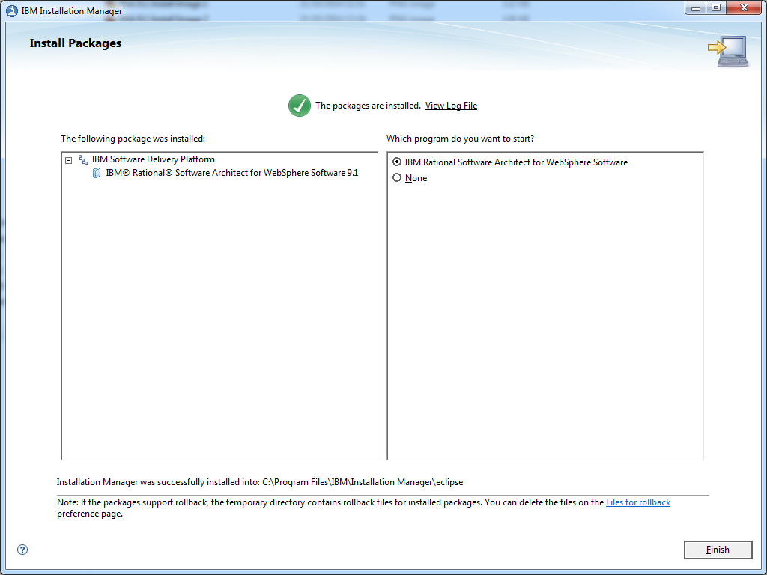

- When a popup box appears asking you to select a workspace, leave the default and click on ‘OK’. 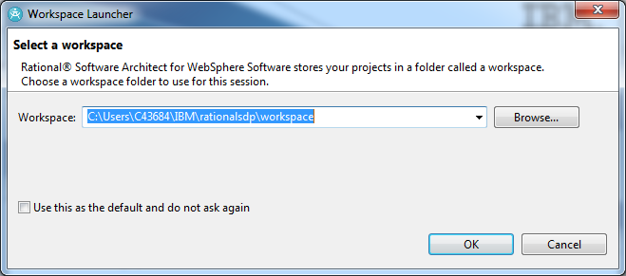
- Click on ‘Manage Licences’ to continue to the next step. 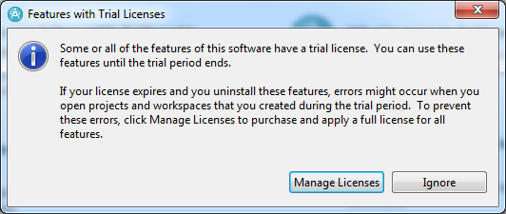

- Highlight ‘Rational Software Architect for WebSphere Software’, as per the below screenshot and then click on ‘Apply License’. 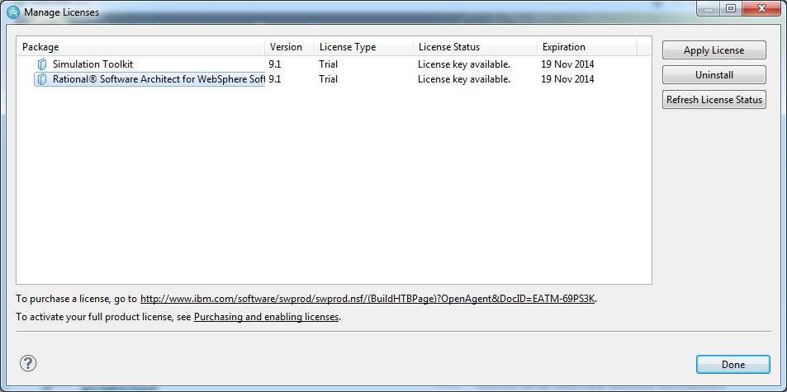
- Select ‘IBM Rational Software Architect for WebSphere Software 9.1’…. And then check the ‘Import product Activation Kit’ radio button. 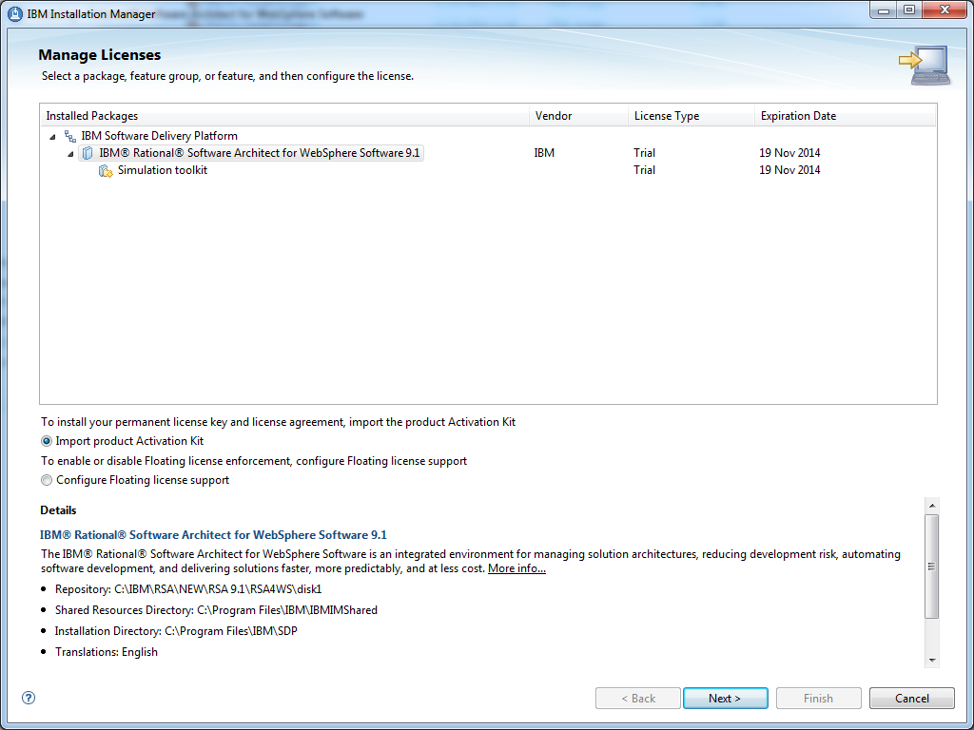

- c
  - Select ‘Browse’ within the repository section and navigate to …\RSA-9.1\Activation_Kit.
  - Highlight the RSAWS-Act-Kit-v91.jar file and click ‘Open’.
Then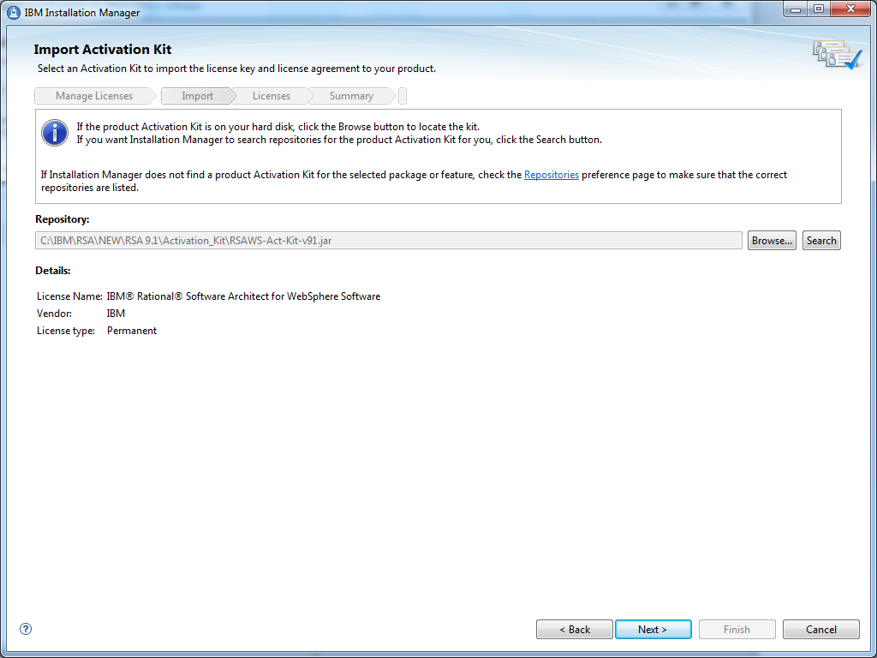
- Once the file has been selected, click on the ‘Next>’ button. The Licenses screen will appear as shown below. Click the radio button for “I Accept the terms in the license agreements” and click the ‘Next>’ button. 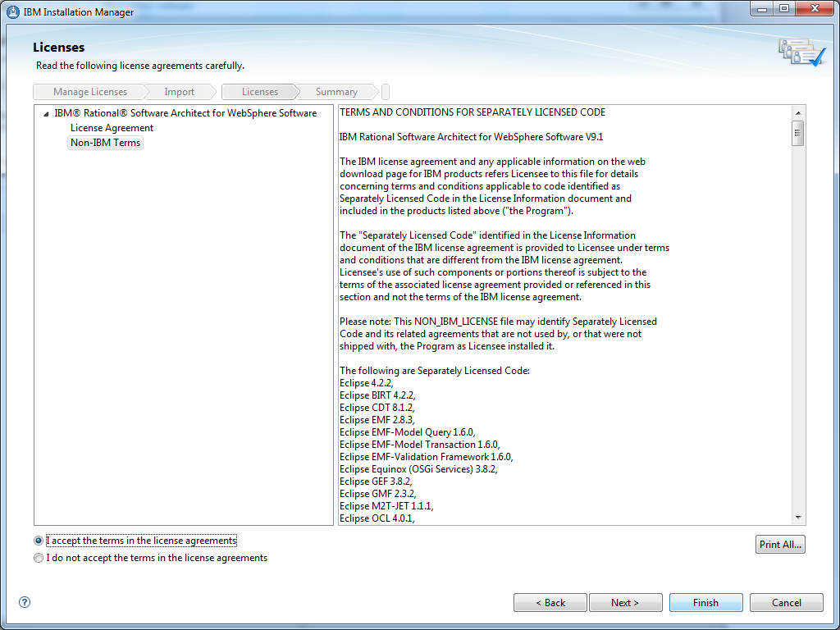
- Click on ‘Finish’ to complete the Installation.
Part 2: Installing the IFW Utilities
Part 2.1
Pre-Conditions: Part 1 must have been completed successfully.
NOTE: Part 2.1 needs to be run for each <PLUGIN> identified below, in the order below:
- ‘com.ibm.ima.soa.ste.rsa.utilities_3.5.1.201312121552’
- ‘com.ibm.ima.soa.ste.rsa.additional.utilities_3.5.1.201312121552’
Plugin Location: <NEM SHARE DRIVE>\Software\ Installers - RSA\RSA utilities\ IFW Plugins
- Copy the <PLUGIN> from the Plugin Location over to your VM.
- Open up RSA 9.1.
- In RSA, navigate to Help -> Install New Software, which will open up the below screen.
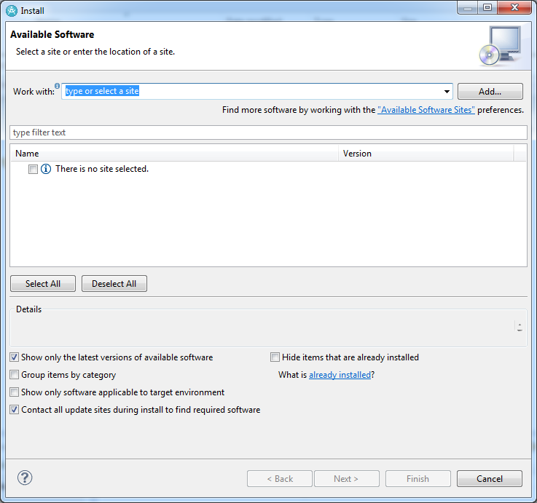

  - Make sure the ‘Group items by category’ check box is NOT selected
  - Click on ‘Add…’
  - Click on ‘Archive…’
  - Navigate to where you saved the <PLUGIN> file on your VM and select it.
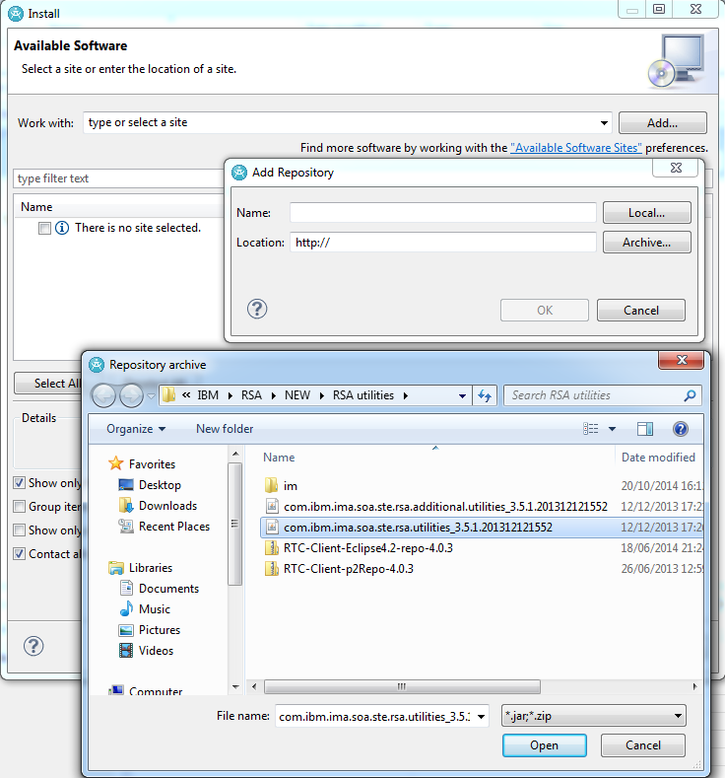

  - Click on ‘Open’
  - Click on ‘OK’
  - Select the checkbox next to ‘IBM Industry Models SOA for Standard Tooling RSA Utilities’
  - Click on ‘Next>’
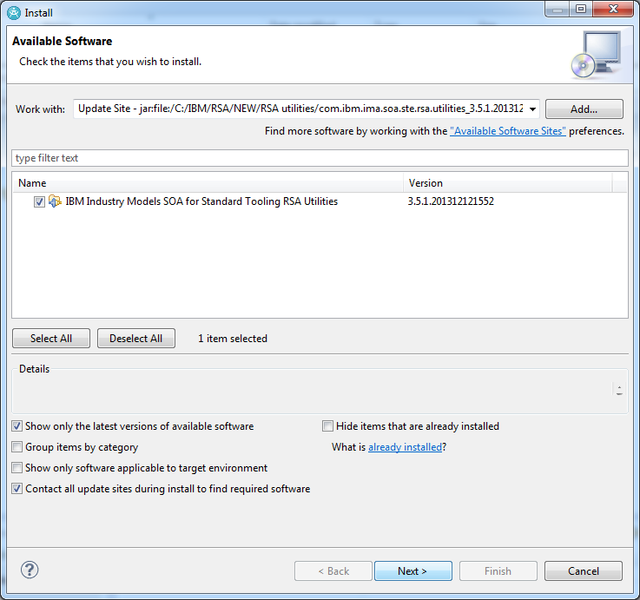
- Click ‘Next>’ on the Install Details screen 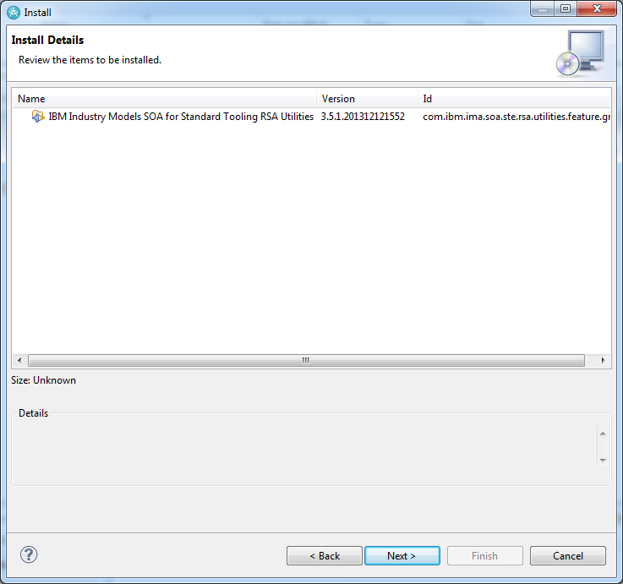
- Select the radio button for “I Accept the terms of the license agreement” and click the ‘Finish’ button.
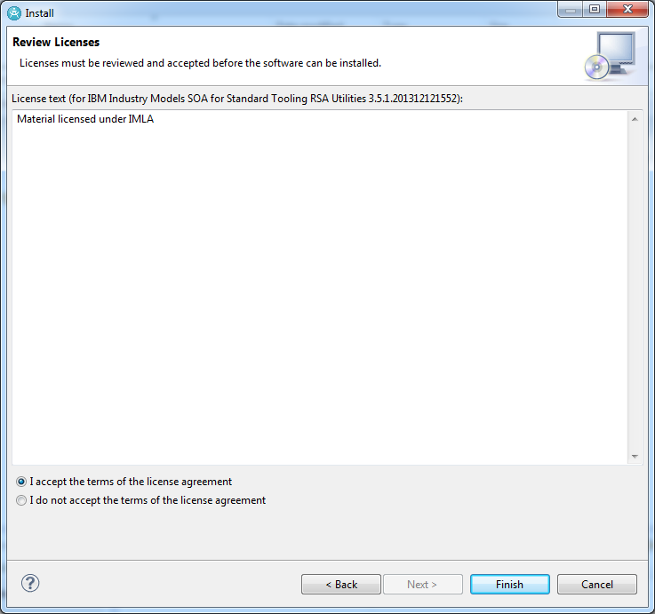
- If a Security Warning popup appears during the installation then select ‘OK’
- Select ‘Yes’ to restart RSA 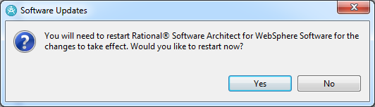
Part 2.2
Pre-Conditions: Part 2.1 must have been completed successfully.
Plugin Location: <NEM SHARE DRIVE>\Software\ Installers - RSA\RSA utilities\ IFW Plugins
- Copy the ‘com.ibm.ima.transform.uml2.wsdl.extension_1.0.8.201406101548’ plugin from the Plugin Location over to your VM into the RSA plugin folder, which should be C:\Program Files\IBM\SDP\plugins
- Navigate to Windows Start button ->All Programs ->IBM Software Delivery Platform ->IBM Rational Software Architect for WebSphere Software 9.1 and then right click on IBM Rational Software Architect for WebSphere and left click on Properties.
- Add – clean to the end of the target as per screen shot below and click on apply. 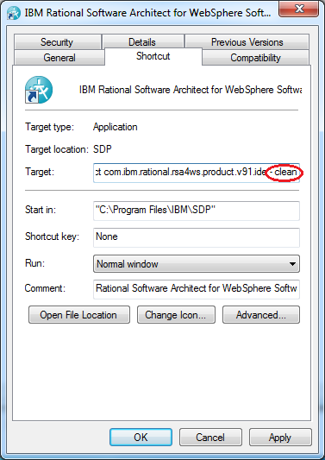
- Open up RSA 9.1.
- Make sure RSA has fully opened, then close RSA 9.1
- Navigate to Windows Start button ->All Programs ->IBM Software Delivery Platform ->IBM Rational Software Architect for WebSphere Software 9.1 and then right click on IBM Rational Software Architect for WebSphere and left click on Properties.
- Remove – clean from the target that was added in step 3.
Part 3: Installing the RTC Plugin
Pre-Conditions:
- Part 1, Part 2.1 & Part 2.2 must have been completed successfully.
- Make sure that RSA (eclipse) is not open.
Utilities Location: <NEM SHARE DRIVE>\Software\ Installers - RSA\RSA utilities\
- Copy the ‘RTC-Client-Eclipse4.2-repo-4.0.3’ zip file from the Utilities Location over to your VM
- Right click on the ‘RTC-Client-Eclipse4.2-repo-4.0.3’ zip file and select ‘Extract All’…’
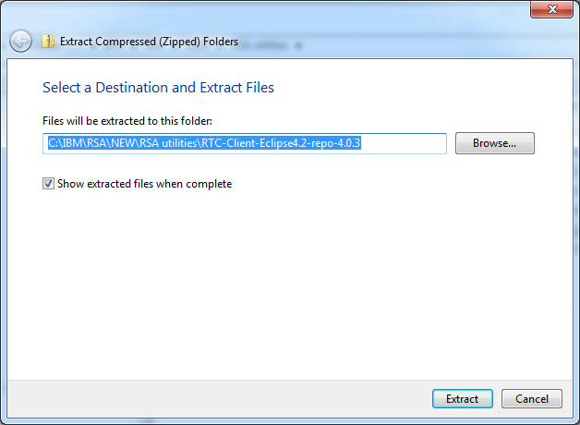
- Click on ‘Extract’ and wait for this to finish.
- Open IBM Installation Manager and navigate to File ->Preferences and then click on ‘Add Repository…’ and then click on ‘Browse…’ and select the ‘repository.config’ file that can be found in ..\RSA utilities\RTC-Client-Eclipse4.2-repo-4.0.3\im\repo\rtc-client-full-p2-offering\offering-repo like the screenshot below.
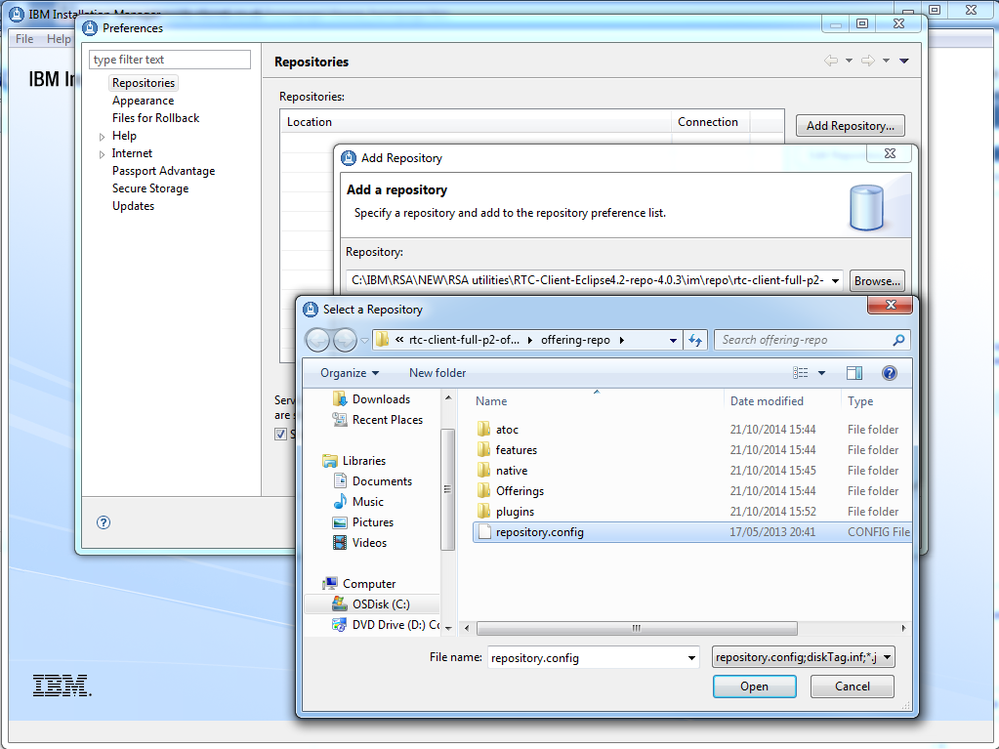
- Click on ‘Open’, then ‘OK’ then ‘Apply’ and then on ‘OK’ and you will be back at the IBM Installation Manager main screen. 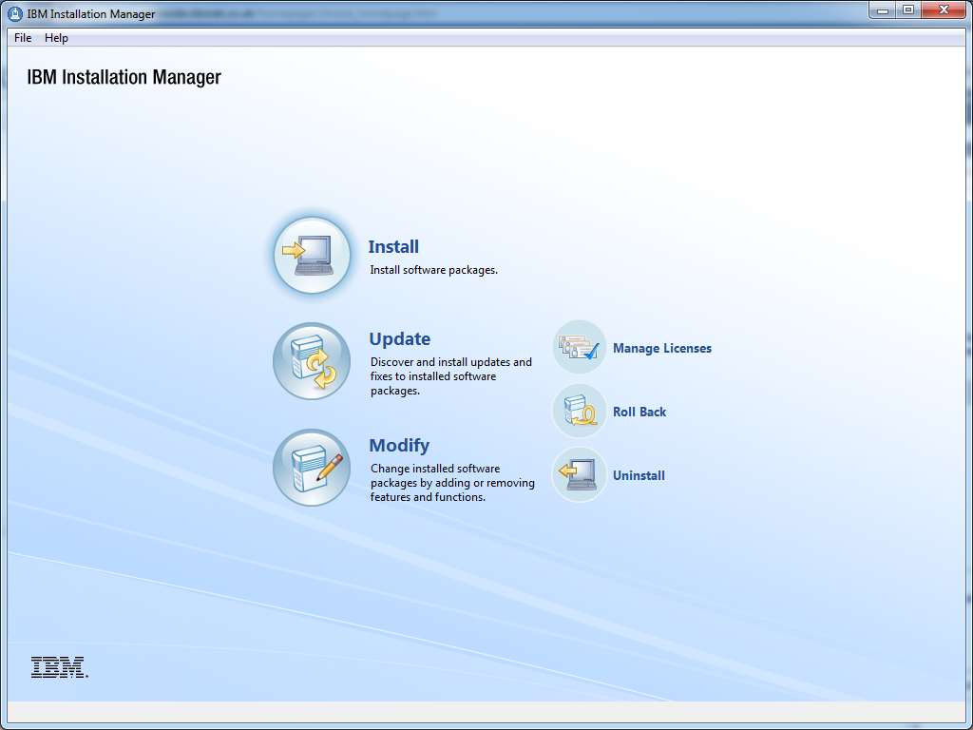
- Select ‘Install’ and then under Installation Packages select the ‘Rational Team Concert – Client for Eclipse 4.2.z IDE’ check box and then click on ‘Next>’ 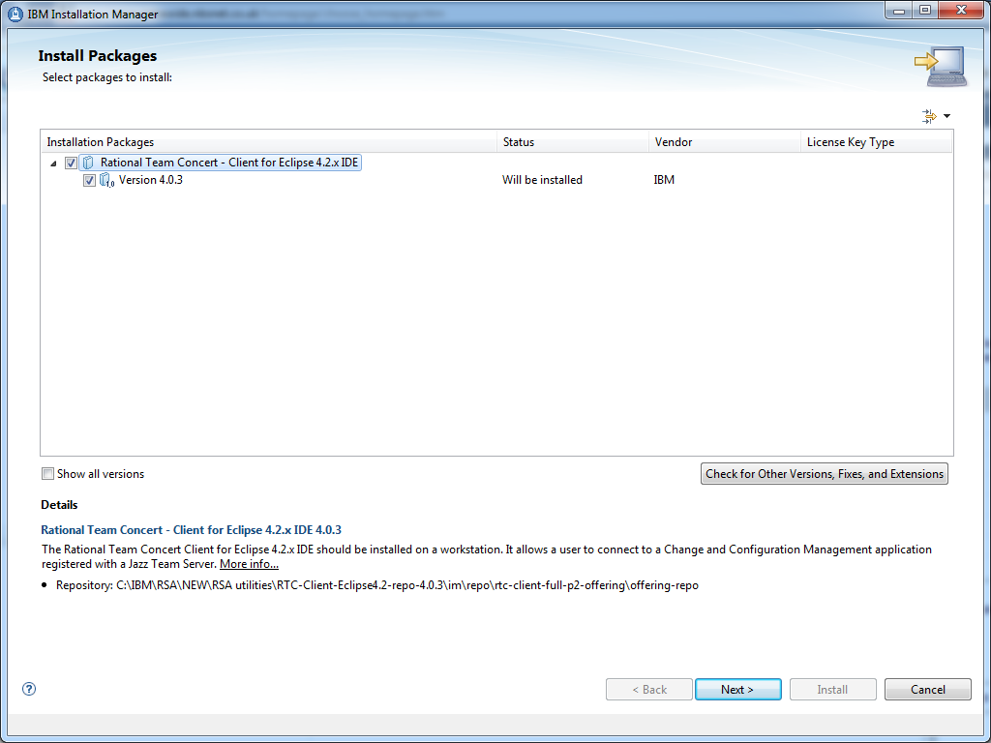
- Select the radio button for “I Accept the terms in the license agreement” and click the ‘Next>’ button. 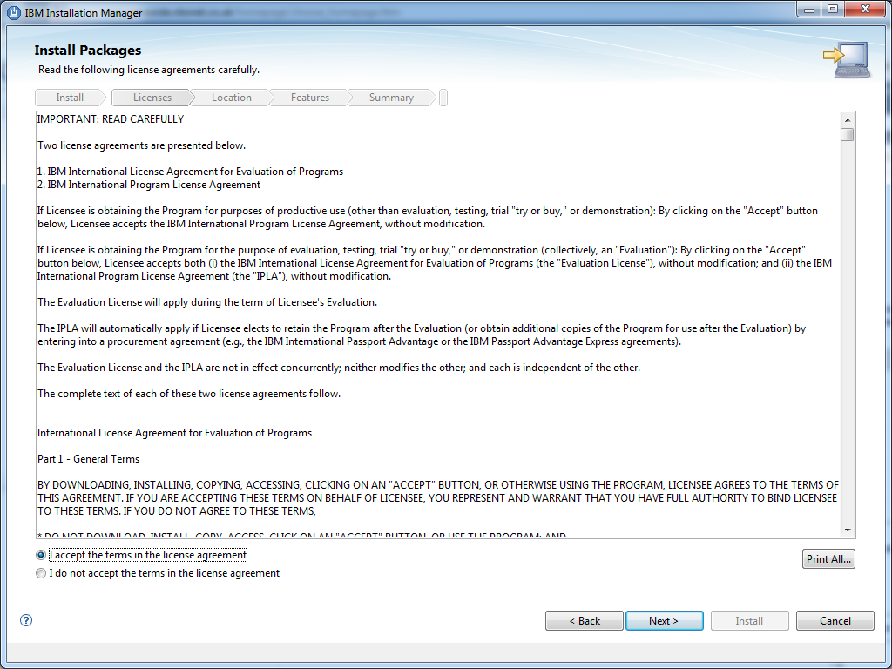
- On the Install Packages screen make sure ‘Use the existing package group’ is selected and then click on ‘Next>’ ***IMPORTANT*** 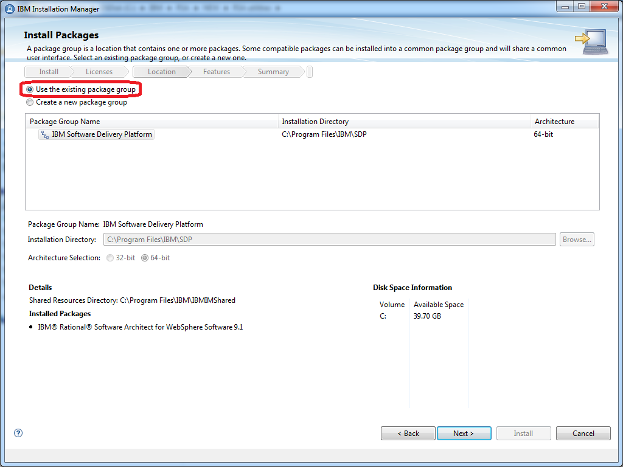
- On the next screen where you are asked to select features, make no changes and click on ‘Next>’ 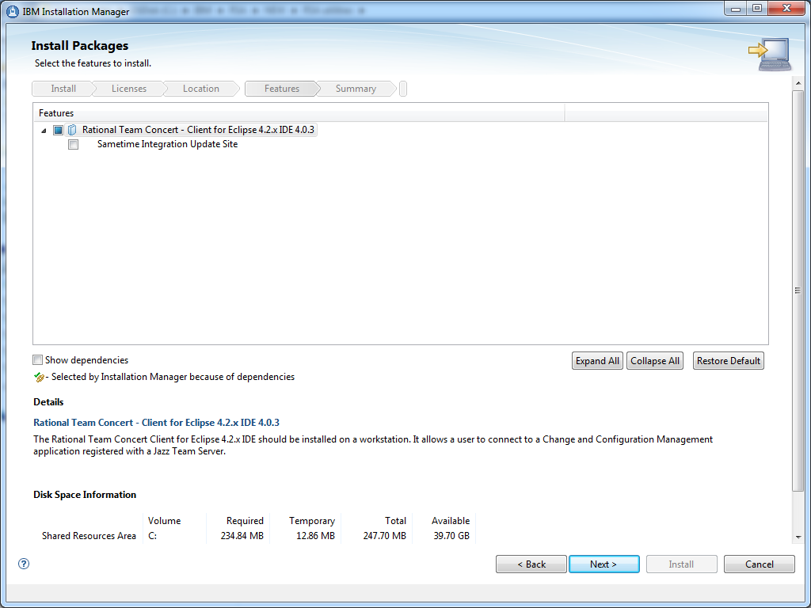
- Choose ‘Access Help from the Web’ and click the ‘Next>’ button to continue.
- At the final summary page, click the ‘Install’ button. 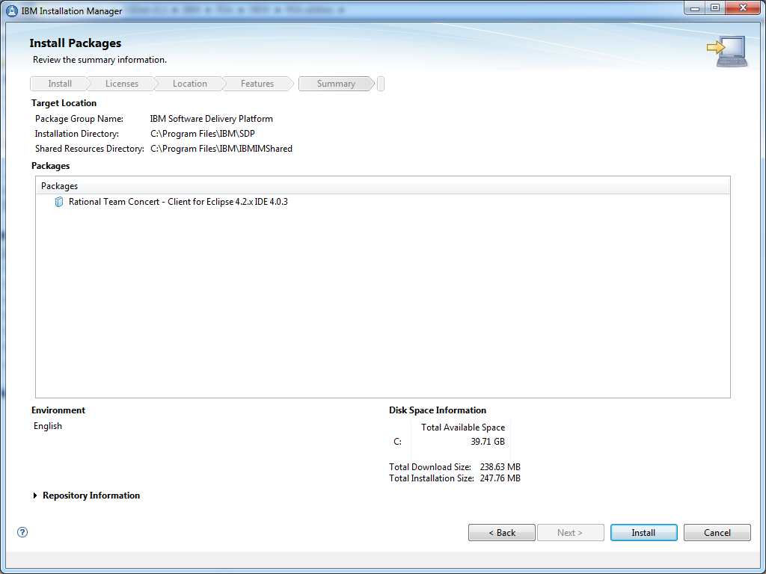
It may take a while for all of the plugin to be installed.
- Once completed, an installation summary screen will be displayed click the ‘Finish’ button.

